**NETWORKING & SYSTEM ADMINISTRATION LAB**

**Experiment No.: 23**

**Aim**

installing docker on ubuntu

**Procedure & Output**

**Steps for Installing Docker:**

**1. Open the terminal on Ubuntu.**

**2. Remove any** [**Docker files**](https://www.simplilearn.com/tutorials/docker-tutorial/what-is-dockerfile) **that are running in the syst**

**em, using the following command:**

**$ sudo apt-get remove docker docker-engine docker.io**

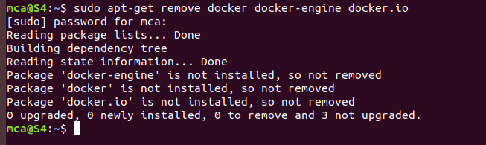

**After entering the above command, you will need to enter the password of the root and press enter.**

**3. Check if the system is up-to-date using the following command**

**$ sudo apt-get update**

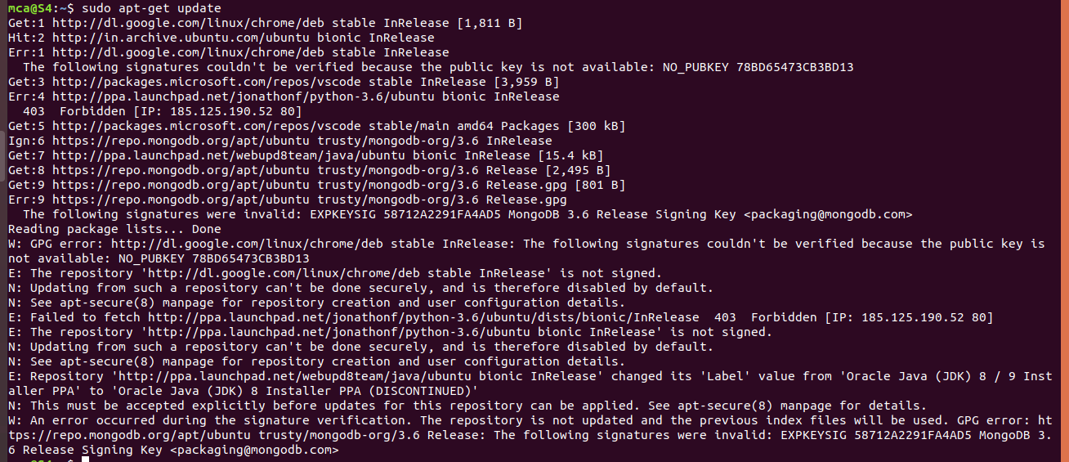

**4. Install Docker using the following command**

**$ sudo apt install docker.io**

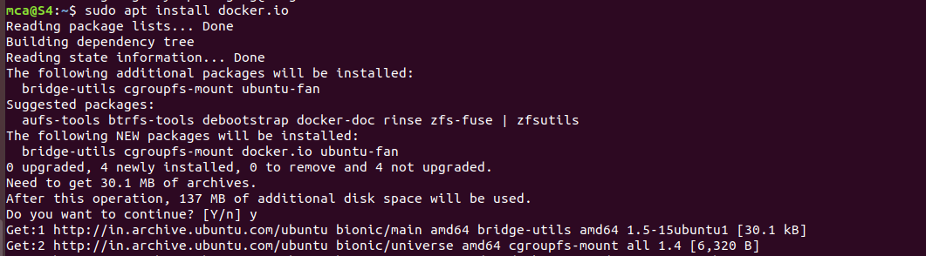

You’ll then get a prompt asking you to choose between y/n - choose *y*

5. Install all the dependency packages using the following command:

| $ sudo snap install docker |
| --- |

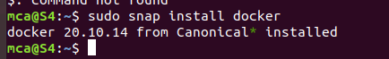

6. Before testing Docker, check the version installed using the following command:

$ docker --version



7. Pull an image from the Docker hub using the following command:

$ sudo docker run hello-world

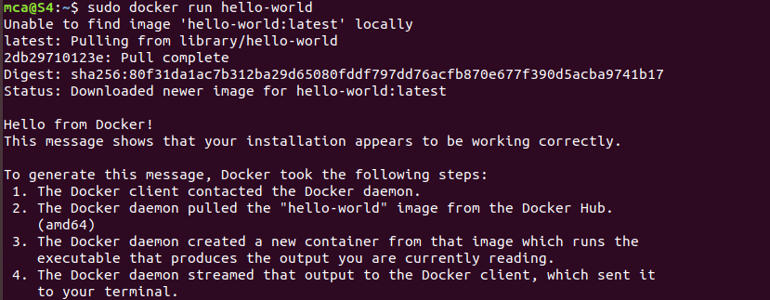

Here, *hello-world* is the docker image present on the Docker hub.

8. Check if the docker image has been pulled and is present in your system using the following command:

$ sudo docker images



9. To display all the containers pulled, use the following command:

$ sudo docker ps -a



10. To check for containers in a running state, use the following command:

$ sudo docker ps

You’ve just successfully installed Docker on Ubuntu!

